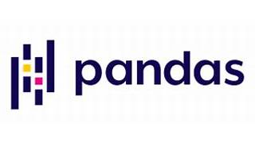



Explore

[**Pandas** is an open-source, BSD-licensed library that provides high-performance, easy-to-use data structures and data analysis tools for the **Python programming language**1](https://pandas.pydata.org/)[2](https://pandas.pydata.org/docs/). It’s widely used for handling and manipulating structured data, including tasks like cleaning, transforming, and analyzing datasets.

Here are **five free reference links** where you can learn more about Pandas:

1. [**Official Pandas Documentation**](https://pandas.pydata.org/docs/): This comprehensive resource covers everything from installation to advanced usage. It includes tutorials, examples, and detailed explanations of Pandas features.
2. [**Pandas Tutorial on W3Schools**](https://www.w3schools.com/python/pandas/default.asp): W3Schools offers a beginner-friendly tutorial that introduces Pandas concepts, including working with Series, DataFrames, reading CSV files, and more.
3. [**Pandas User Guide**](https://pandas.pydata.org/): Dive deeper into Pandas with this user guide. It provides in-depth information on various topics, such as data manipulation, indexing, and merging datasets.
4. [**Pandas Cheat Sheet**](https://pandas.pydata.org/): A concise reference sheet summarizing essential Pandas functions and methods. Great for quick look-ups while working with data.
5. **DataCamp Pandas Tutorial**: DataCamp offers interactive Pandas tutorials. While some content requires a subscription, there are free sections available to get you started.

Happy learning! 🐼📊